Topic List - Maths Mock Assessment

* Frequency Polygons – What?
* Rules for Powers
* Pythagoras = $a^{2}+b^{2}= c^{2}$
* Sector area $=\frac{Angle}{360}×πr^{2}$
* Sine rule – Used to find missing sides or angles
* Expanding Brackets
* Area
* Density – Mass / Volume
* Solving Quadratic inequality
* Cumulative Frequency
* Calculations with Upper and Lower bounds
* Functions
* Probability
* Quadratic Sequences – Nth term sequences where the nth rule changes by a constant amount 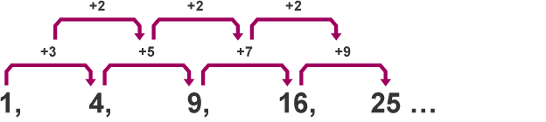
* Ratio
* Congruency
* HCF
* Currency Conversions
* Conversion Graphs
* Transformations
* Recognising Types of Graphs

15 / 21 Good

5 / 21 Meh

1 / 21 Aaahhh